Jeanette Pranin

HW#4 Writeup

**Part 1:**

|  |
| --- |
| **ORIGINAL IMAGES** |
| Exposure: 7838 |
| Exposure: 15676 |
| Exposure: 31352 |
| Exposure: 62704 |
| Exposure: 125408 |

The problems that arose from taking the pictures were due to a faulty aspect of the Nvidia code. The hotfix did allow us to take pictures without an issue.

**Part 2:**

1. Response curve for red, green, and blue channels. Adjusting the parameter for gsolve.

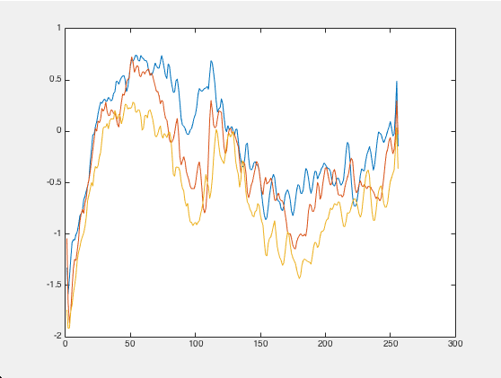 l = 5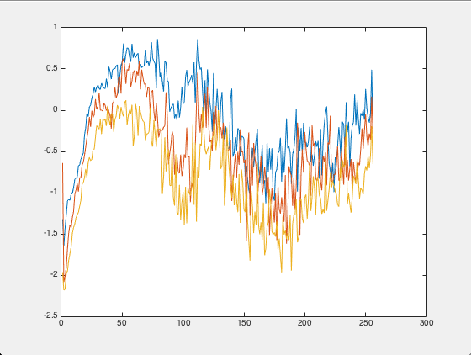l = 0.1

If we adjust this parameter to be a higher value, the response curves becomes much smoother

1. 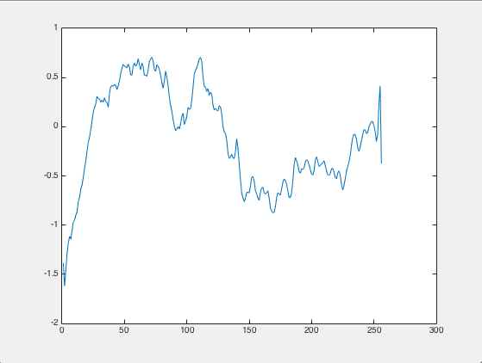

^^Response curve for red channel^^

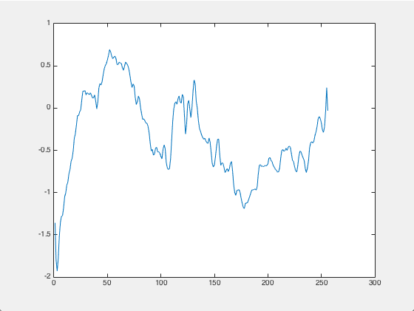

^^Response curve for green channel^^

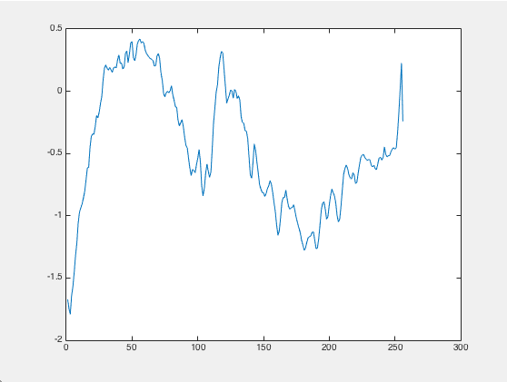

^^Response curve for blue channel^^

1. 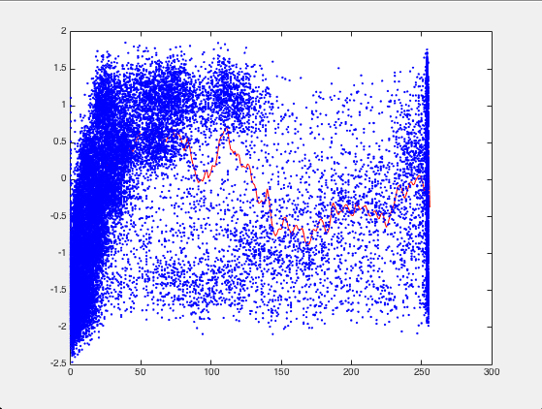

^^Response curve for red channel with pixel data^^

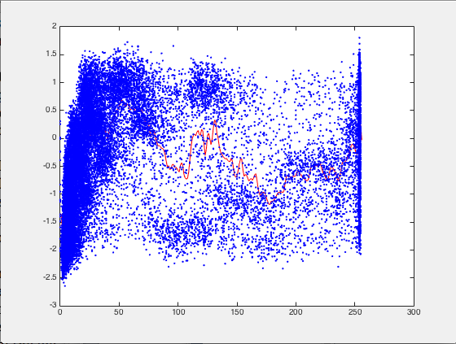

^^Response curve for green channel with pixel data^^

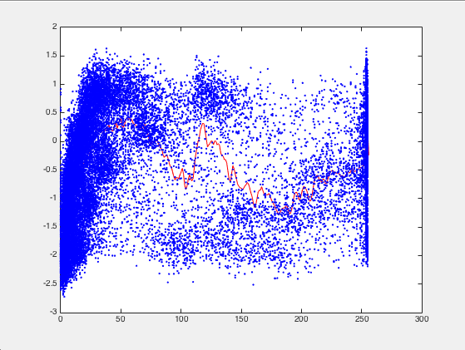

^^ Response curve for blue channel with pixel data^^

**Part 3:**

1. 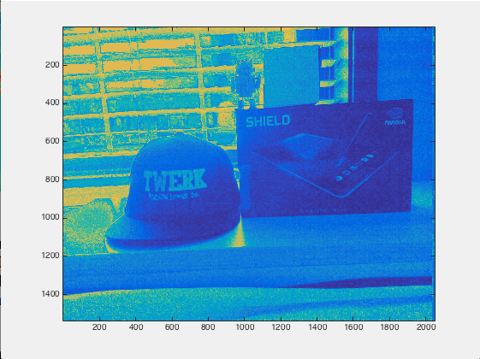

^^Radiance map for red^^

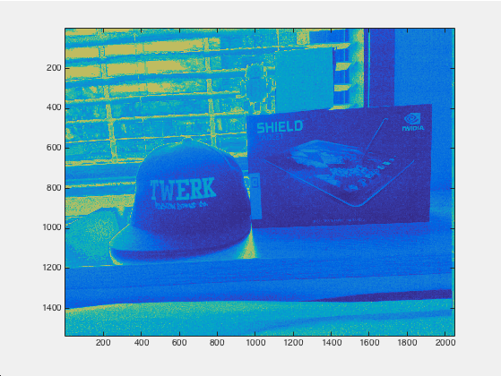

^^Radiance map for green^^

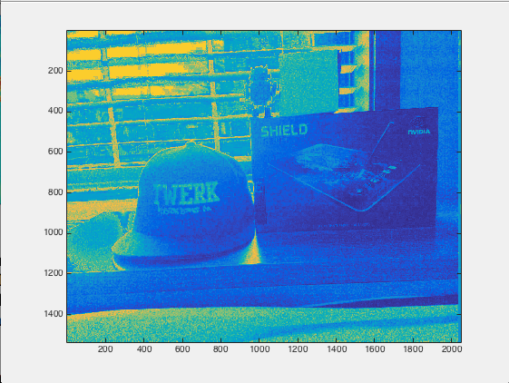

^^Radiance map for blue^^

1. The dynamic range of our scene is 14.0239.

**Part 4:**

1. 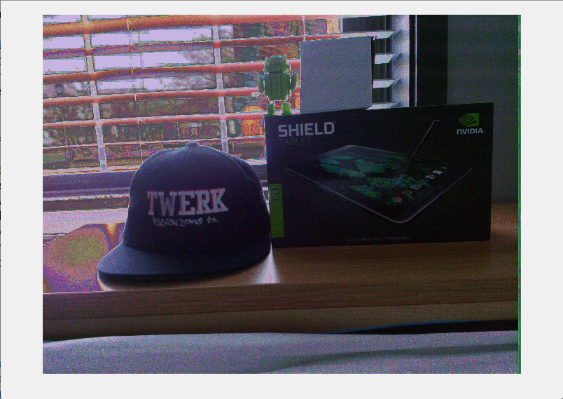

^^Enorm = our normalized image^^

1. 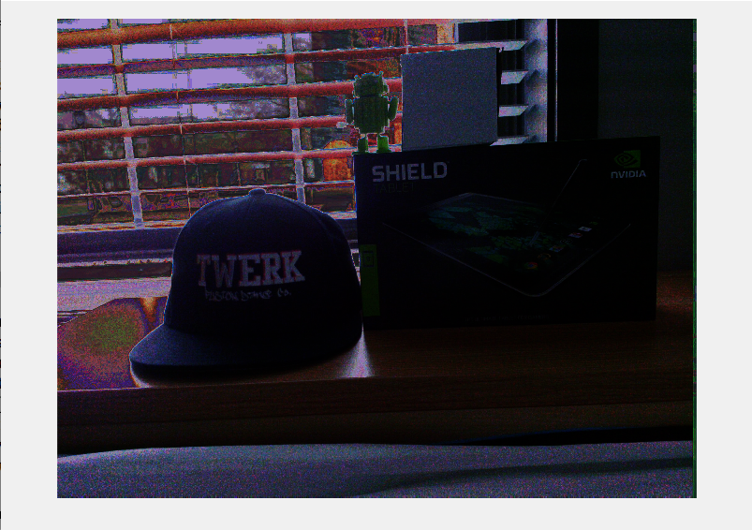

^^Egamma: gamma = 1.8^^

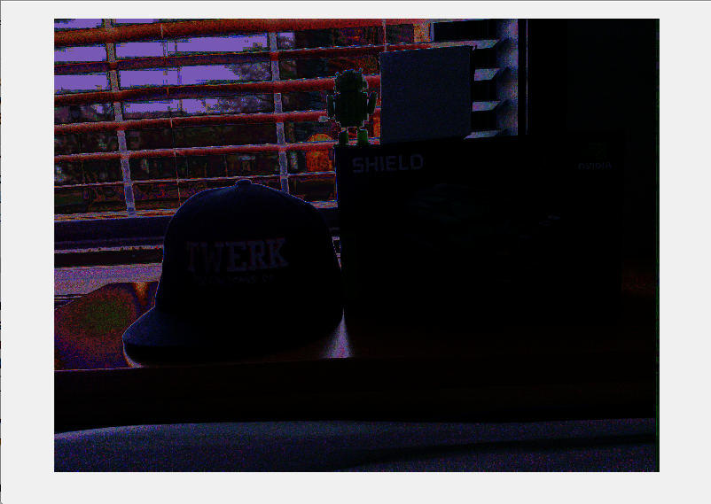

^^Egamma: gamma = 3.0^^

The higher the value the gamma, the darker the image because the irradiance of each pixel is raised to be higher.

1. 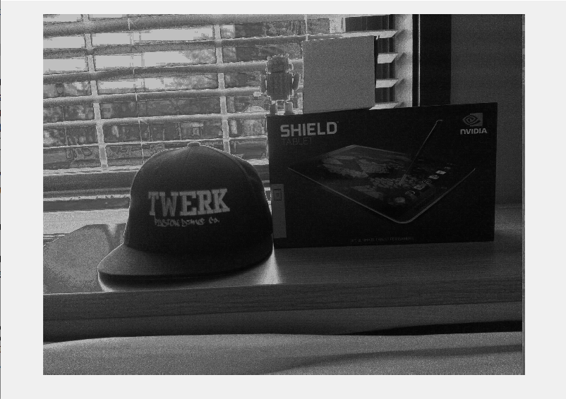

Radiance image in grayscale

1. 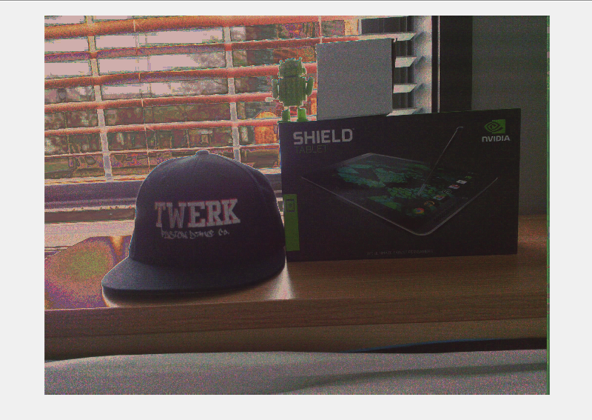

^^We found visually pleasing results with a = 0.18^^

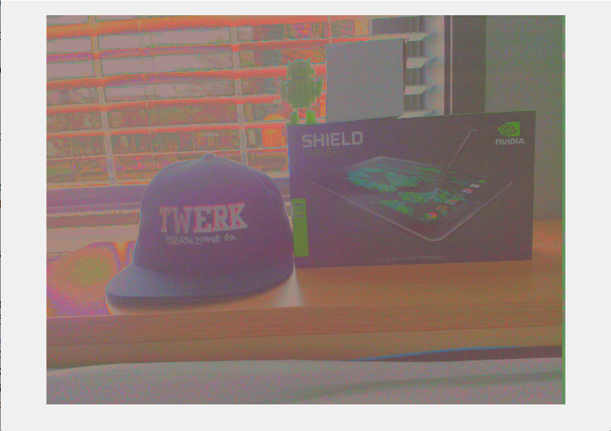

^^a = 1^^

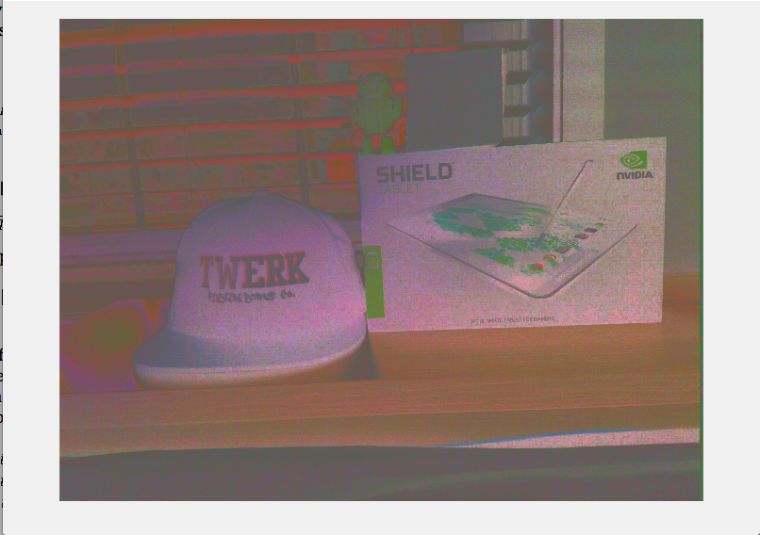

^^a = 5^^